Problem Statement
You are an analyst in the Credit Risk / Asset-Liability Management team at Apex National Bank. Senior management and the regulator need a clear, reproducible measure of how fast the bank’s total loan portfolio has grown over the last two decades. This figure informs capital planning, stress-testing assumptions and ICAAP discussions.

Solution Strategy
1. Store bank name and the two endpoint loan-portfolio values in variables. 2. Compute absolute change, convert to percentage growth, then divide by elapsed years (arithmetic mean). 3. Wrap the calculation in a reusable function that prints a narrative sentence suitable for a risk report. 4. Provide vector / data-frame alternates and the geometric (CAGR) rate preferred by risk managers. 5. Add a simulation block so parameters can be changed for target-setting or stress scenarios.

Solution — Key R Snippets
Core result (2005–2025): Absolute change = $114,200 m; percentage growth ≈ 402 %; arithmetic annual ≈ 20.11 %/yr. Geometric / CAGR (preferred) ≈ 8.40 %/yr.
Variable creation & arithmetic:
bank_name <- "Apex National Bank"
loans_year_one <- 28400
loans_year_two <- 142600
loan_change <- loans_year_two - loans_year_one
percentage_gr <- (loan_change / loans_year_one) * 100
annual_gr <- percentage_gr / (2025 - 2005) # ≈ 20.11
Function call (produces the risk narrative):
result <- calculate_annual_growth(
year_one = 2005, year_two = 2025,
value_y1 = loans_year_one, value_y2 = loans_year_two,
entity = bank_name)
→ “From 2005 to 2025 the loan portfolio of Apex National Bank grew by approximately 20.1056 % each year.”
Geometric / CAGR (use this for capital planning):
cagr <- (142600 / 28400)^(1/20) - 1
print(cagr * 100) # ≈ 8.40
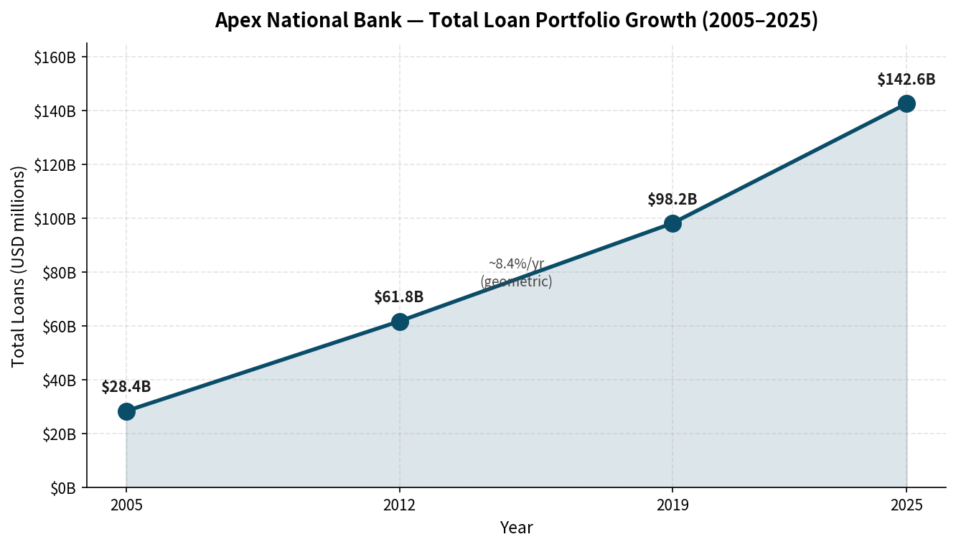
Figure: Apex National Bank total loans 2005–2025. Period rates: 2012–2019 ≈ 8.43 %/yr; 2019–2025 ≈ 7.54 %/yr.
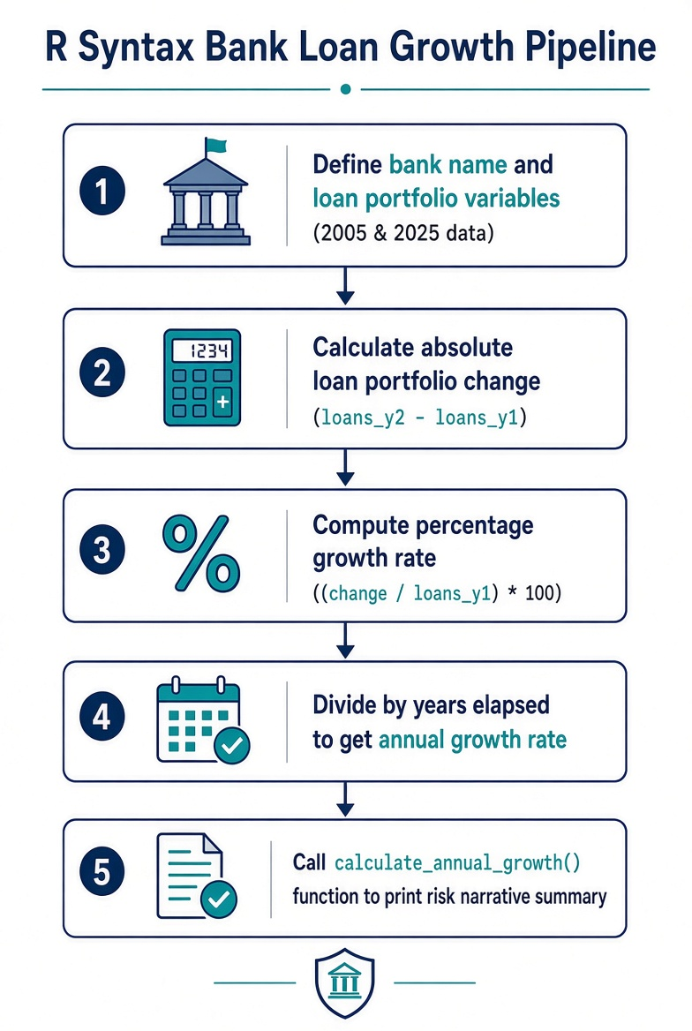
Figure: R Syntax Bank Loan Growth Pipeline.

Key Takeaways
• Variables + arithmetic + paste() turn raw balance-sheet numbers into an actionable growth narrative for risk committees.
• Named function arguments make the logic reusable across banks, product books or time windows.
• Arithmetic averages are easy but overstate long-horizon growth; risk teams almost always prefer CAGR for ICAAP and stress testing.
• A parameterised simulation cell lets planners explore target loan-book sizes or stress scenarios without rewriting core code.
• Audience note: for executives keep the CAGR + one-sentence narrative prominent; for technical risk staff expose both methods and intermediate variables.

